EX NO : 1 | DEVELOPING STATIC WEBPAGE USING BASIC HTML
DATE : | DEVELOPING STATIC WEBPAGE USING BASIC HTML

QUESTION 1 :
Create a page that will display an image that has a border of size 2, awidth of 200, and a height of 200.

AIM :
To develope a static webpage using HTML .

CODE :
<html>
<head>
<title> IMAGE ! </title>
</head>
<body>
<img src="/home/dhinesh/Downloads/vinayakaa.jpeg" alt="Vinayakar is there!"
width="200" height="200" border="2" >
</body>
</html>

OUTPUT :

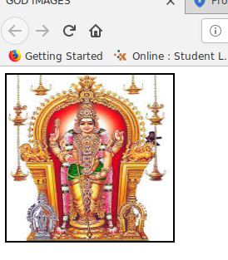

RESULT :
Thus, the display an image example was designed using HTML .

EX NO : 1 | DEVELOPING STATIC WEBPAGE USING BASIC HTML
DATE : | DEVELOPING STATIC WEBPAGE USING BASIC HTML

QUESTION 2 :
Create a page which contains two links- one at the top and one at thebottom. On clicking the top link, the page has to scroll down to the bottom of the page where bottom link is present. On clicking the bottom link, the page has to scroll up to the top of the page.

AIM :
To develope a static webpage using HTML .

CODE :
<html>
<head>
<title>Bookmark</title>
</head>
<body>
<a href="#Bottom">Go down...</a>
<h4 id="Top">This is the first page</h4>
<br><br><br><br><br><br><br><br><br><br><br><br><br><br><br><br>
<br><br><br><br><br><br><br><br><br><br><br><br><br><br><br><br>
<br><br><br><br><br><br><br><br><br><br><br><br><br><br><br><br>
<a href="#Top">Go up...</a>
<h4 id="Bottom">This is the last page</h4>
</body>
</html>

OUTPUT :

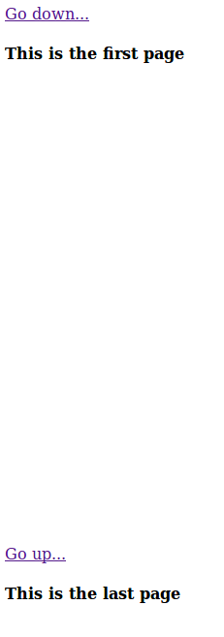

RESULT :
Thus, the given Bookmark example was designed using HTML .

EX NO : 1 | DEVELOPING STATIC WEBPAGE USING BASIC HTML
DATE : | DEVELOPING STATIC WEBPAGE USING BASIC HTML

QUESTION 3:
Design Html page that display the following content.

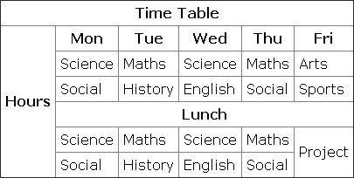

AIM :
To develope a static webpage using HTML .

CODE :
<html>
<head>
<title> TIME TABLE ! </title>
</head>
<body>
<table border="20" align="center">
<tr><th colspan ="6"> TIME TABLE</tr></th>
<tc><th rowspan="7">HOURS</tc></th>

<tr>
<th>MON</th>
<th>TUE</th>
<th>WED</th>
<th>THU</th>
<th>FRI</th>
</tr>

<tr>
<td><font color="orangered"> Science</td>
<td><font color="darkgreen"> Maths</td>
<td><font color="orangered"> Science</td>
<td><font color="darkgreen"> Maths</td>
<td><font color="purple"> Arts</td></tr>
<tr>
<td><font color="darkcyan"> Social</td>
<td><font color="deeppink"> History</td>
<td><font color="indigo"> English</td>
<td><font color="darkcyan">Social</td>
<td><font color="yellowgreen">Sports </td>
</tr>

<tr>
<th colspan="5">LUNCH</tr></th>
<td><font color="orangered"> Science</td>
<td><font color="darkgreen"> Maths</td><td><font color="orangered"> Science</td>
<td><font color="darkgreen"> Maths</td>
<td rowspan="2"><font color="deepskyblue">Project </td>
</tr>

<tr>
<td><font color="darkcyan"> Social</td>
<td><font color="deeppink"> History</td>
<td><font color="indigo"> English</td>
<td><font color="darkcyan">Social</td>
</tr>
</body>
</html>

OUTPUT :
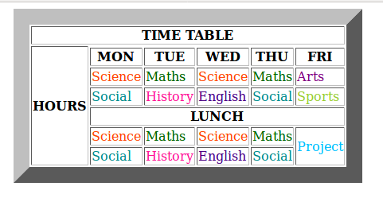

RESULT :
Thus, the given Table example was designed using HTML .

EX NO : 2 | DEVELOPING STATIC WEBPAGE USING  HTML LISTS AND FORMS
DATE : | DEVELOPING STATIC WEBPAGE USING  HTML LISTS AND FORMS

QUESTION 1 :
Create a webpage that prints three lists with any information you want. One list should be an ordered list and the other lists should be an unordered list and glossary list.

AIM :
To develope a static webpage using HTML Lists .

CODE :
<html>
<head>
<title> LISTS ! </title>
</head>
<body>

<h1><u>UNORDERD LIST</u></h1>
<ul style="list-style-type:circle">
<li>Mechanical</li>
<li>Automobile</li>
<li>Civil</li>
</ul>

<h1><u>ORDERED LIST</u></h1>
<ol type="A">
<li>ETE</li>
<li>EIE</li>
<li>CSE</li>
</ol>

<h1><u>GLOSSARY LIST</u></h1>
<dl>
<dt>Data Structures</dt>
<dt>Machine Learning</dt>
<dt>Artificial Inteligence</dt>
</dl>
</body>
</html>

OUTPUT :

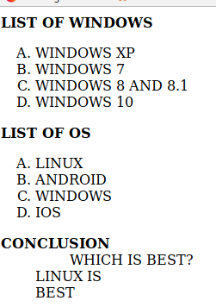

RESULT :
Thus, the given list example was designed using HTML Lists .

EX NO : 2 | DEVELOPING STATIC WEBPAGE USING  HTML LISTS AND FORMS
DATE : | DEVELOPING STATIC WEBPAGE USING  HTML LISTS AND FORMS

QUESTION 2 :
Design a HTML page as shown in figure using form tags.

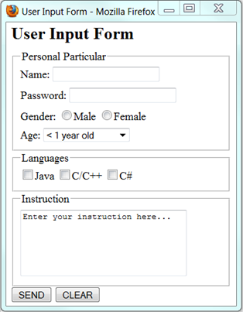

AIM :
To develope a static webpage using HTML Forms .

CODE :
<!DOCTYPE HTML>
<html>
<head>
<title> FORM !</title>
<h1><b> User Input Form </b></h1>
</head>
<body>

<fieldset>
<legend>Personal Particular</legend>
Name : <input type="text" name="Name" value=""><br><br>
Password : <input type="password" name="Password" value=""><br><br>
Gender : <input type="radio" name="Gender" value="">Male
<input type="radio" name="Gender" value="">Female<br>

Age:<select>
<option value="<1yearold"> <1yearold</option>
<option value="<5yearold"> <5yearold</option>
<option value="<10yearold"> <10yearold</option>
<option value="<15yearold"> <15yearold</option>
<option value="<20yearold"> <20yearold</option>
</select>
</fieldset>

<fieldset><legend>Languages</legend>
<input type="checkbox" name="Language" value="">Java
<input type="checkbox" name="Language" value="">c/c++
<input type="checkbox" name="Language" value="">Python
</fieldset>

<fieldset>
<legend>Instructions</legend>
<textarea placeholder="Enter the instructions here..."></textarea>
</fieldset>
<input type="submit" value="Send">
<input type="reset" value="Clear">
</body>
</html>

OUTPUT :

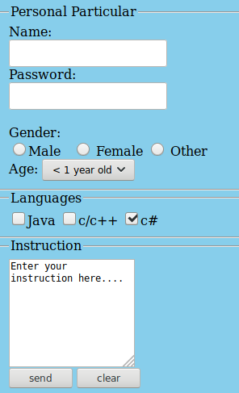

RESULT :
Thus, the given Form example was designed using HTML Forms .

EX NO : 3 | DEVELOPING STATIC WEBPAGE USING HTML FRAMES
DATE : | DEVELOPING STATIC WEBPAGE USING HTML FRAMES

QUESTION 1 :
Design a website for a startup company that contains the following features.

- Website should have at least three page.
- Home page should have the links to other two pages and should have frame.
- Any one page should have tables to represent the data.o Any one page should
have background image.
- Display an image that when clicked will link to a search engine of your choice
(should be opened in a new window)
- Pages with a link at the top of it that when clicked will jump all the way to the
bottom of the page. At the bottom of the page there should be a link to jump back to the top of the page.

AIM :
To develope a static webpage using HTML Frames .

CODE :
Part 1 :
<html>
<head>
<title>Company site</title>
</head>
<frameset rows="30%,70%">
<frame src="dino8.2.html">
<frame src="dino8.4.html">
</frameset>
</html>

Part 2 :
<html>
<head>
<title>Company site</title>
<body align="center" background="images.jpeg">
<img src="12.jpeg" align="right" height="250" width="250" >
</body></head>
</html>

Part 3 :
<html>
<head>
<title>Company site</title>
</head>
<body>
<h6 id="TOP">
<a href="#BOTTOM" align="right" >BOTTOM</a>
<h3><u>ETAILIO</u></h3>
<p>
Even before academic studies began, Americans were enthralled by the Robber baron debate. As the United States industrialized very rapidly after the Civil War, a few hundred prominent men made large fortunes by building and controlling major industries, such as railroads, shipping, steel, mining and banking. Yet the newer who gathered the most attention was railroader Cornelius Vanderbilt. Historian Stephen Frazier argues that probably most Americans admired Vanderbilt; they agreed with biographer William Augustus Croffut who wrote in 1886..</p>
<h4>HISTORY</h4>
<ol type="A">
<li>It is now known that the desire to own property is the chief difference between the Savage and the enlightened man; that aggregations of money in the hands of individuals are in inestimable blessing to Society, for without them there could be no public improvements or private enterprises, no railroads or steamships, or telegraphs; no cities, the leisure class, no schools, colleges, literature, art – in short, no civilization. The one man to whom the community owes most is the capitalist, that the menu gives, but the man who saves and invests, so that his property reproduces and multiplies itself instead of being consumed.</li>
<li>A minority were irate and excoriated the titans of finance and industry as 'robber barons' and worse. E.L. Godkin, founder of The Nation, launched a volley of invective at the new plutocracy: 'kings of the street' like Vanderbilt displayed 'unmitigated and immitigable selfishness' as appalling as their 'audacity, push, unscrupulousness and brazen disregard of others' rights'.</li>
<li>Biographies of Mellon, Carnegie and Rockefeller were often laced with moral censure, warning that 'tories of industry' were a threat to democracy and that parasitism, aristocratic pretension and tyranny have always trailed in the wake of concentrated wealth, whether accumulated dynastically or more impersonally by the faceless corporation. This scholarship, and the cultural persuasion of which it was an expression, drew on a deeply rooted sensibility–partly religious, partly egalitarian and democratic–that stretched back to William Jennings Bryan, Andrew Jackson and Tom Paine.</li>
<li>Nevins argued that economic development in the United States caused relatively little human suffering, while raising the general standard of living and making the United States the great industrial power capable of defeating Germany in both world wars. The great capitalists of that period should, he argued, be viewed, not as 'robber barons', but as men whose economic self- interest had played an essentially positive role in American history, and who had done nothing criminal by the standards of their time.</li>
</ol>
<h5>Other Things.....</h5>
<table border="20" align="center" style="width:70%">
<tr><th align="center">Starting..</th>
<td align="center">With 35 years of sports intelligence, STATS powers sports. </td></tr>
<tr><th align="center">Performance</th><td align="center">We are trusted by millions of fans and athletes around the globe to analyze performance data from more than 100,000 games a year with unrivaled speed and accuracy.</td></tr>
<tr><th colspan="2"><img src="com1.jpg" align="center" height="200"
width="200" ><img src="com2.png" align="center" height="200" width="200" ></th>
</tr>
<tr><th align="center">Therapy File</th>

<td align="center"><ul><li>Outpatient & Emergency Services</li><li>Date of
Service</li> <li>Type of Service</li><li>Procedure Code</li></ul></td></tr>
</table>
<h2 align="center">................................</h2>
<h6 id="BOTTOM">
<a href="#TOP" align="right">TOP</a>
</body>
</html>

Part 4 :
<html>
<head>
<title>Company site</title>
</head>
<frameset cols="10%,90%">
<frame src="dino8.5.html">
<frame src="dino8.3.html">
</frameset>
</html>
Part 5 :
<html>
<head>
<title>Company site</title>
</head>
<body>
<a href="https://www.dhineshkumar2611@gmail.com" target="_blank"><img align="center"
src="mail.jpeg" height="75" width="75"></a><br><br><br><br>
<a href="https://naimeo.com/name/etailio/" target="_blank"><img align="center"
src="etailio.jpeg" height="75" width="75"></a>
</body>
</html>

OUTPUT :

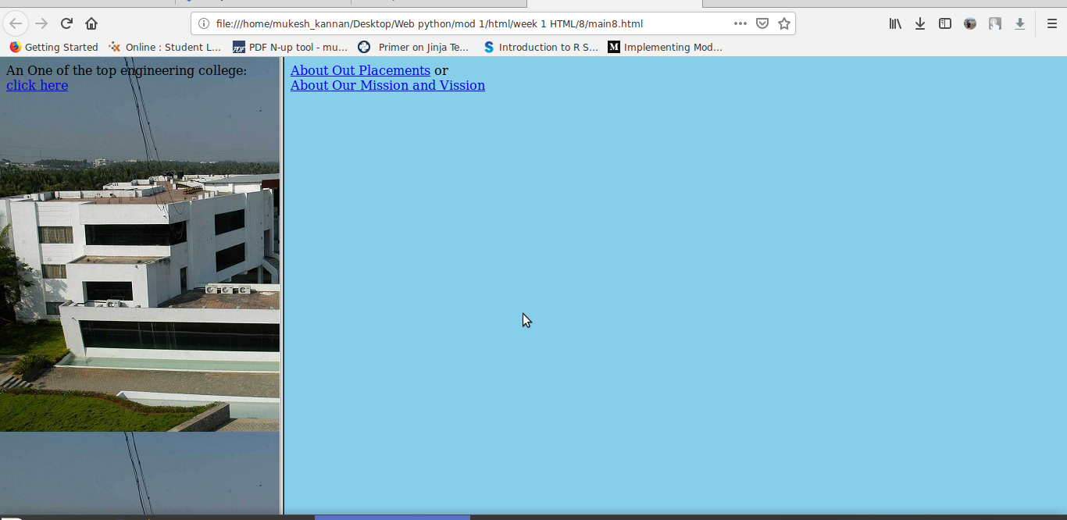

RESULT :
Thus, the given Frame example was designed using HTML Frames.

EX NO : 4 | DEVELOPING STATIC WEBPAGE USING CSS CLASS SELECTOR AND CSS ID SELECTOR
DATE :

QUESTION 1 :
Create a webpage that displays the div element with the following properties.
- Alignment: Center
- Font Size : 27pixels
- Font Name: Arial
Note: Use css Id selector

AIM :
To develope a static webpage using CSS id selector .

CODE :
!DOCTYPE html>
<html>
<head>
<style>
#wadp {
font-family:Arial;
font-size:27px;
text-align:center;
}
</style>
</head>

<body>
<h1>.....Welcome.....</h1>
<div>
<p id="wadp">Web Application Development Using Python</p>
</div>
<p>..Thank You..</p>
</body>
</html>

OUTPUT :

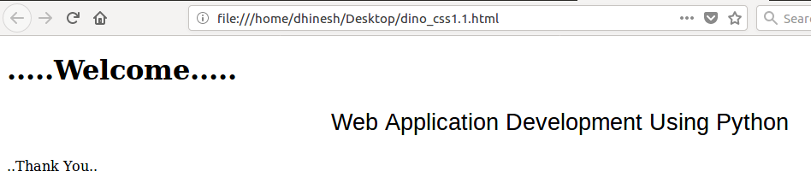

RESULT :
Thus, the given text example was designed using CSS Id selector.

EX NO : 4 | DEVELOPING STATIC WEBPAGE USING CSS CLASS SELECTOR AND CSS ID SELECTOR
DATE :

QUESTION 2 :
Create a webpage that displays the div element with the following properties.
- Alignment: Center
- Font Size : 25pixels
- Font Name: Verdana
Note: Use css class selector

AIM :
To develope a static webpage using CSS class selector .

CODE :
!DOCTYPE html>
<html>
<head>
<style>
.wadp {
font-family:Verdana;
font-size:25px;
text-align:center;
}
</style>
</head>

<body>
<h1>.....Welcome.....</h1>
<div>
<p class="wadp">Web Application Development Using Python</p>
</div>
<p>..Thank You..</p>
</body>
</html>

OUTPUT :

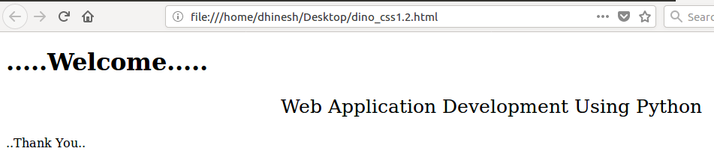

RESULT :
Thus, the given text example was designed using CSS Class selector.

EX NO : 5 | DEVELOPING WEBPAGE USING EXTERNAL STYLE SHEET
DATE : | DEVELOPING WEBPAGE USING EXTERNAL STYLE SHEET

QUESTION 1 :
Create a webpage that displays the div element with the following font properties.
- Font family: Verdana
- Font style: italic
- Font size: 20pixels
- Text align: left
- Font weight: bold
- Text color: Red
Use External Style sheet
AIM :
To develope a webpage using External Style sheet .

CODE :
css file
div{
font-family:Verdana;
font-style: italic;
font-size:20px;
text-align:left;
font-weight: bold;
color:Red;
}

HTML file
<html>
<head>
<link rel="stylesheet" type="text/css" href="dino_css1.7.css" />
</head>
<body>
<div>..Karpagam College Of Engineering.. </div>
</body>
</html>

OUTPUT :

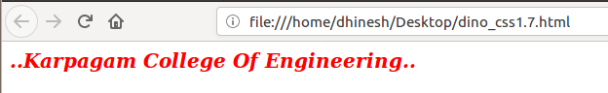

RESULT :
Thus, the given text example was designed using using External Style sheet .
EX NO : 6 | DEVELOPING WEBPAGE USING INLINE STYLE  SHEET AND INTERNAL STYLE SHEET
DATE :

QUESTION 1 :
Create a webpage that displays the div element with the following attributes.
- Font name: Verdana
- Font size: 20 pixels
- Color: red
- Align: center
Note: Use Inline style sheet
AIM :
To develope a webpage using Inline Style sheet .

CODE :
<!DOCTYPE html>
<html>
<head>
<div style="font-family:Verdana;font-size:20px;text-align:center;color:red">
<p><b><u>Web Application Development Using Python Labarotary</u></b></p>
<ul style="list-style-type:circle">
<li>HTML</li>
<li>CSS</li>
<li>Boostrap</li>
</ul>
</div>
</head>
</html>

OUTPUT :

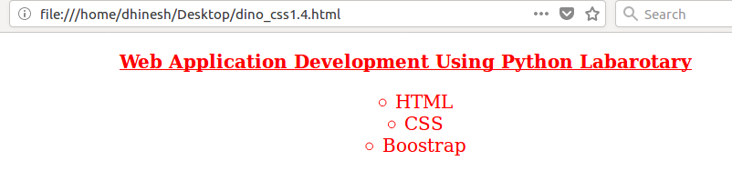

RESULT :
Thus, the given text example was designed using using Inline Style sheet .

EX NO : 6 | DEVELOPING WEBPAGE USING INLINE STYLE  SHEET AND INTERNAL STYLE SHEET
DATE :

QUESTION 2 :
Create a webpage that displays the div element with the following text properties.
- Text color: Magenta
- Text alignment: right
- Text decoration: underline
- Text transform: uppercase
- Text indent: 60 pixels
Use Internal Style Sheet
AIM :
To develope a webpage using Internal Style sheet .

CODE :
<html>
<head>
<style>
p{
color:magenta;
text-align:right;
text-decoration: underline;
text-transform: uppercase;
font-size:30px;
}
</style>
<body>
<p> KCE was established with the vision of providing cutting edge technical education and
to create proficient engineers. The college is accredited by NAAC with ‘A’ Grade, TCS, Wipro and NBA . KCE strives to impart quality education and an excellent career start to all its students.</p>
</body>
</head>
</html>

OUTPUT :

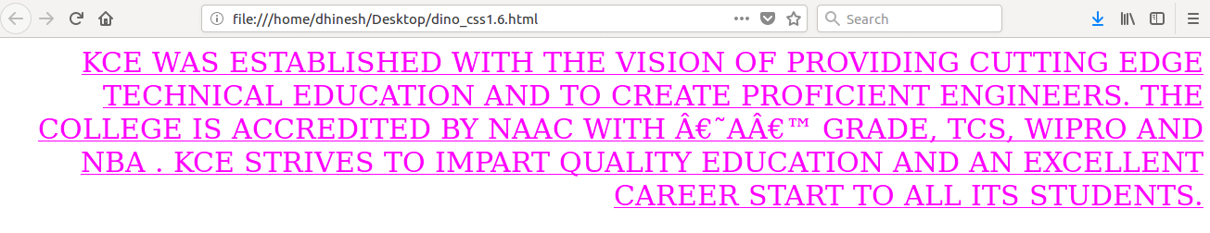
RESULT :
Thus, the given text example was designed using using Internal Style sheet .
EX NO : 7 | DEVELOPING WEBPAGE USING HTML AND CSS 3
DATE : | DEVELOPING WEBPAGE USING HTML AND CSS 3

QUESTION 1 :
Create a webpage that displays the hyperlink with the following color attributes.
- Set the color as %FF0000 for unvisited link
- Set the color as %FF00 for visited link
- Set the color as %FF00FF for mouse over link
- Set the color as %0000FF for selected link

AIM :
To develope a webpage using HTML and CSS 3.

CODE :
<html>
<head>
<style>

a:link {
color: %FF0000;
}

a:visited {
color: %FF00;
}

a:hover {
color: %FF00FF;
}

a:active {
color: %0000FF;
}

</style>
</head>
<body>
<p><b><a href="http://kce.ac.in" target="_blank">Karpagam College of Engineering
</a></b></p>
</body>
</html>

OUTPUT :

Link :

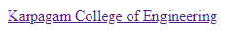

Hover :

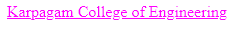

Visited :

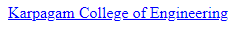

RESULT :
Thus, the given hyperlink example was designed using HTML and CSS 3 .

EX NO : 7 | DEVELOPING WEBPAGE USING HTML AND CSS 3
DATE : | DEVELOPING WEBPAGE USING HTML AND CSS 3

QUESTION 2 :
Create a webpage that displays a list as an ordered list with the following properties.
- List-style-type: lower-greek;
- Text align: left
- Color: red
- Text transform: uppercase
- Text decoration: underline
- Font name: Verdana
- Font size: 20pixels
- Font weight: bold

AIM :
To develope a webpage using HTML and CSS 3.

CODE :
<html>
<head>
<style>
div{
text-align:left;
color:red;
text-transform: uppercase;
text-decoration: underline;
font-family:Verdana;
font-size:20px;
font-weight: bold;
}
</style>

<body>
<p align="center"><u><font size="6">KCE BEST DEPARTMENTS</font></u></p>
<div>
<ol style="list-style-type:lower-greek">
<li>Mechanical</li>
<li>ece</li>
<li>ete</li>
<li>eie</li>
<li>It</li>
<li>Cse</li>
</ol>
</div>
</body>
</head>
</html>

OUTPUT :

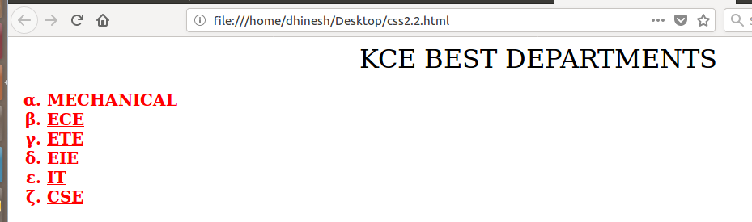

RESULT :
Thus, the given text example was designed using HTML and CSS 3 .

EX NO : 7 | DEVELOPING WEBPAGE USING HTML AND CSS 3
DATE : | DEVELOPING WEBPAGE USING HTML AND CSS 3

QUESTION 3 :
Create a webpage that displays the paragraph with the following properties.
- Set the width of the border as 10 Pixels.
- Set the style of the border as dotted.
- Set the color of the border as #0000ff

AIM :
To develope a webpage using HTML and CSS 3.

CODE :
<html>
<head>
<style>
p.covai{
border-width: 10px;
border-style: dotted;
border-color: #0000ff;
}
</style>
</head>
<body>
<p class="covai"><font size="6">...Coimbatore is called the <b>"Manchester of South
India"</b>...</font></p>
</body>
</html>

OUTPUT :

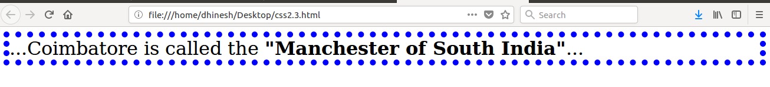

RESULT :
Thus, the given border example was designed using HTML and CSS 3 .

EX NO : 8 | DEVELOPING WEBPAGE USING HTML AND CSS 3
DATE : | DEVELOPING WEBPAGE USING HTML AND CSS 3

QUESTION 1 :
Create a webpage that displays three paragraphs with the following margin properties.
- Set the top margin as 3cm for first paragraph
- Set the bottom margin as 5cm for first paragraph
- Set the left margin as 2cm for second paragraph
- Set the top margin as 25% for third paragraph
AIM :
To develope a webpage using HTML and CSS 3.

CODE :
<!DOCTYPE html>
<html>
<head>
<style>
p.chennai{
margin-top: 3cm;
margin-bottom: 5cm;
}
p.covai{
margin-left: 2cm;
}
p.madurai{
margin-top: 25%;
}
</style>
</head>

<body>
<p class="chennai"><font size="6">Chennai is nicknamed "The Detroit of India", with more than
one-third of India's automobile industry being based in the city.</font></p>
<p class="covai"><font size="6">Coimbatore is called the "Manchester of South India" due to its
extensive textile industry, fed by the surrounding cotton fields.</font></p>
<p class="madurai"><font size="6">Madurai is called with various nicknames like Athens of the
East, Thoonga Nagaram (City that never Sleeps), Naan maada koodal (City of Four junctions),
Malligai Managar (City of Jasmine), Koodal Managar (City of Junction) Koil Nagar (Temple city)
etc.</font></p>
</body>
</html>

OUTPUT :

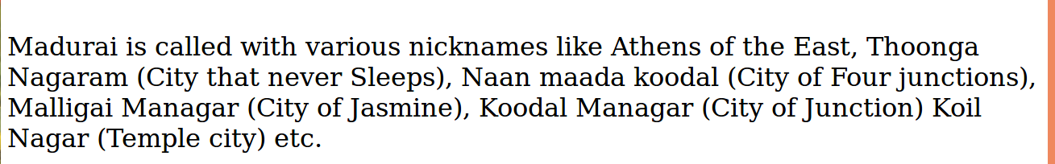
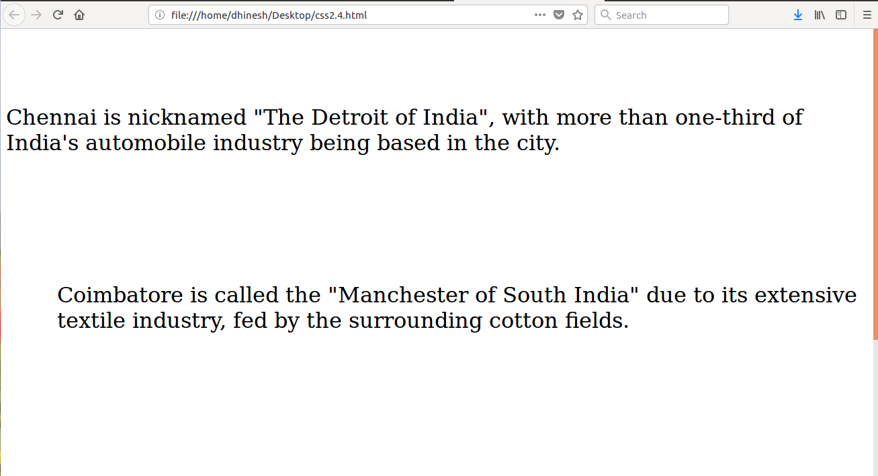

RESULT :
Thus, the given margin example was designed using HTML and CSS 3 .
EX NO : 8 | DEVELOPING WEBPAGE USING HTML AND CSS 3
DATE : | DEVELOPING WEBPAGE USING HTML AND CSS 3

QUESTION 2 :
Create a webpage that displays an image as the background around an element with the following properties.
- Border: 1pixels solid black
- Height: 150pixels
- Width: 180pixels
- Background : url (imagename.gif)
- Background-repeat: no-repeat
- Background-size: cover

AIM :
To develope a webpage using HTML and CSS 3.

CODE :
<html>
<head>
<style>
div {
border: 1px solid black;
height: 150px;
width: 180px;
background-image: url("is.gif");
background-repeat: no-repeat;
background-size: cover;
}
</style>
</head>
<body>
<div>
</div>
</body>
</html>

OUTPUT :

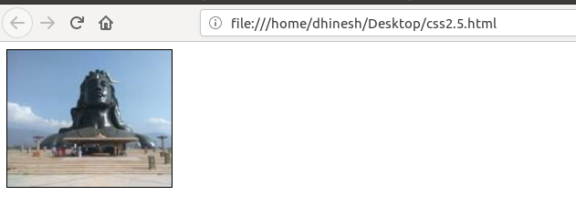

RESULT :
Thus, the given image example was designed using HTML and CSS 3 .

EX NO : 9 | DEVELOPING WEBPAGE USING BOOSTRAP
DATE : | DEVELOPING WEBPAGE USING BOOSTRAP

QUESTION 1 :
Create a webpage to display Tulips.jpg from sample pictures of your machine. Ensure the image has soft round edges and as you resize the screen, the image should also resize itself and fit its display to full page size.

AIM :
To develope a webpage using Boostrap .

CODE :
<!DOCTYPE html>
<html>
<head>
<title>Title</title>
<link rel="stylesheet"href="https://maxcdn.bootstrapcdn.com/bootstrap/4.3.1/css/ bootstrap.min.css">
</head>
<body>
<img src="Tulips.jpg" class="rounded" alt="Image is Here!" width="50%" height="60%">
</body>
</html>

OUTPUT :

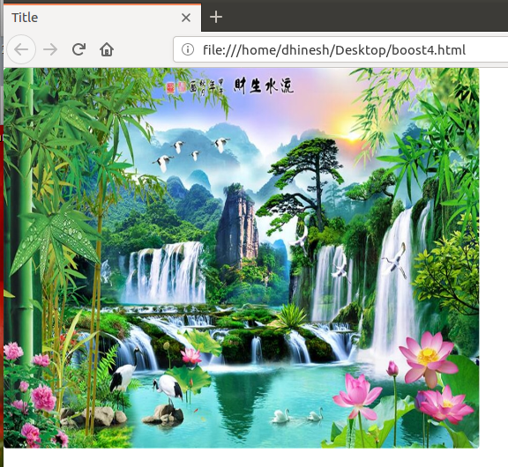

RESULT :
Thus, the given image example was designed using Boostrap .
EX NO : 9 | Developed WEBPAGE USING BOOSTRAP
DATE : | Developed WEBPAGE USING BOOSTRAP

QUESTION 2 :
Create a webpage called OnlineRead with give look and feel Page should display Book Types as buttons with given background effect:
- For All – white
- Kids – bark blue
- Teens – Green
- Scientific – Light Blue
- Crime – OrangeHorror – red
- Feedback – shown
In next line display the comfort font size with buttons of varying sizes ranging from big to small (in 4 steps).

AIM :
To develope a webpage using Boostrap .

CODE :
<!DOCTYPE html>
<html>
<head>
<title>Online_Read</title>
<link rel="stylesheet"
href="https://maxcdn.bootstrapcdn.com/bootstrap/4.3.1/css/bootstrap.min.css">
<style>
.btns{
display:block;
margin-left: 25%;
}
</style>
</head>

<body>
<br>
<div class="btns">
<button type="button" class="btn btn-success">Teens</button><br><br>
<button type="button" class="btn btn-secondary">Kids</button><br><br>
<button type="button" class="btn btn-warning">Crime</button><br><br>
<button type="button" class="btn btn-light">For_All</button><br><br>
<button type="button" class="btn btn-info">Scientific</button><br><br>
<textarea name="commentbox"rows="4" cols="45">
Please Enter Your Comment!!

</textarea>
</div>
</body>
</html>

OUTPUT :

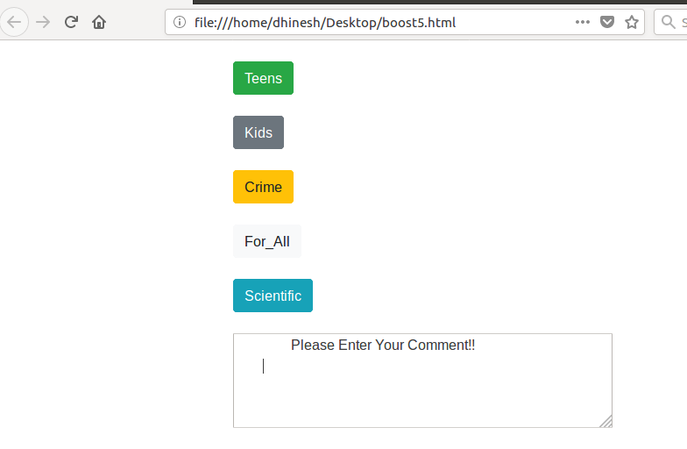

RESULT :
Thus, the given button example was designed using Boostrap .

EX NO : 10 | Developed WEBPAGE WITH TABLES USING BOOSTRAP
DATE : | Developed WEBPAGE WITH TABLES USING BOOSTRAP

QUESTION 1:
Create a small table with 2 columns Name and contact no, Populate the table with 5 of your friends names and their contact nos. When the mouse is taken over the table it should highlight the row where the mouse is placed.(hint : use table hover)

AIM :
To develope a webpage with tables using Boostrap .

CODE :
<!DOCTYPE html>
<html>
<head>
<link rel="stylesheet"
href="https://maxcdn.bootstrapcdn.com/bootstrap/3.4.0/css/bootstrap.min.css">
<style type="text/css">
tbody tr:hover{
background-color: #ff3374;
}
</style>
</head>

<body>
<table class="table">
<thead>
<tr>
<th>NAME</th>
<th>CONTACT_NO</th>
</tr>
</thead>

<tbody>
<tr>
<td>DhineshKumar</td>
<td>9626645663</td>
</tr>
<tr>
<td>Manivasaham</td>
<td>9943332046</td>
</tr>
<tr>
<td>Akash</td>
<td>9626643487</td>
</tr>
<tr>
<td>Senthur</td>
<td>9665545663</td>
</tr>
<tr>
<td>Altrin</td>
<td>9626658763</td>
</tr>
</tbody>
</table>
</body>
</html>

OUTPUT :

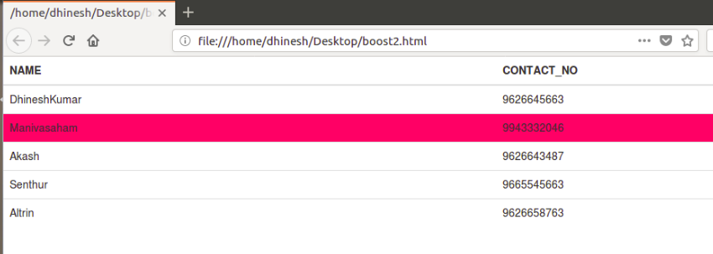

RESULT :
Thus, the given table example was designed using Boostrap .

EX NO : 10 | Developed WEBPAGE WITH TABLES USING BOOSTRAP
DATE : | Developed WEBPAGE WITH TABLES USING BOOSTRAP

QUESTION 2:
Create a table of food contents with its calorie value. Display the rows of food contents with calories
- <=300 in light green background,
- 301 to 700 in light blue,
- 700 - 1200 in light orange
- >1200 in light red.
(Hint: use table table-striped)

AIM :
To develope a webpage with tables using Boostrap .

CODE :
<!DOCTYPE html>
<html>
<head>
<title>Title</title>
<link rel="stylesheet"
href="https://maxcdn.bootstrapcdn.com/bootstrap/4.3.1/css/bootstrap.min.css">
</head>
<body>
<table class="table table-striped">
<thead>
<th>Food_Contents</th>
<th>Calorie_Value</th>
</thead>
<tbody>
<tr style="background-color: #00FF7F">
<td>Rasgulla</td>
<td>140</td>
</tr>
<tr style="background-color: #ADD8E6">
<td>Baked Beans</td>
<td>310</td>
</tr>
<tr style="background-color: #FFA500">
<td>Briyani</td>
<td>750</td>
</tr>
<tr style="background-color: #FA8072">
<td>Chicken</td>
<td>1300</td>
</tr>
<tr style="background-color: #00FF7F">
<td>Carrot Halwa</td>
<td>165</td>
</tr>
<tr style="background-color: #FA8072">
<td>Beef Briyani</td>
<td>1600</td>
</tr>
<tr style="background-color: #FFA500">
<td>Dosa(Masala)</td>
<td>725</td>
</tr>
<tr style="background-color:#ADD8E6">
<td>Cake(Rich Chocolate)</td>
<td>420</td>
</tr>
</tbody>
</table>
</body>
</html>

OUTPUT :

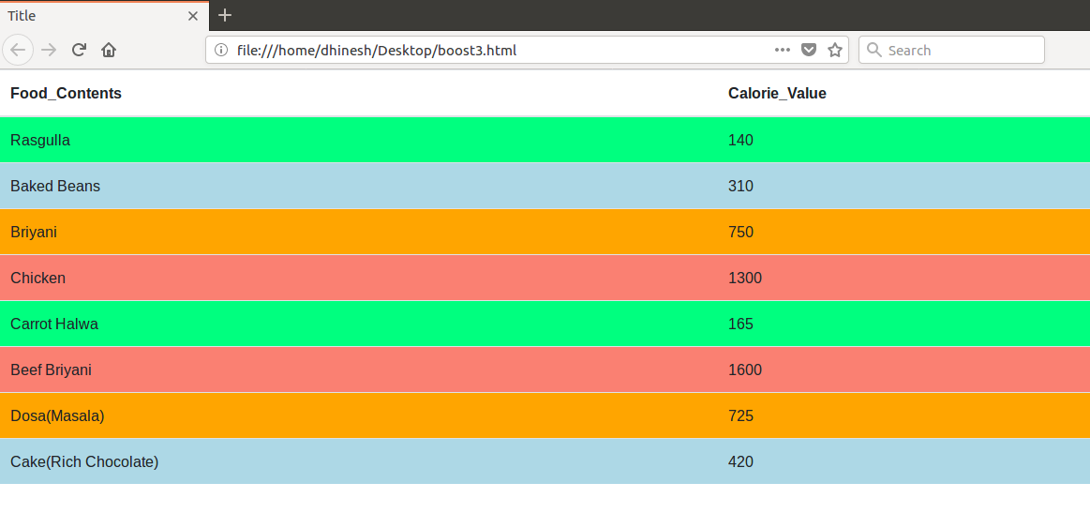

RESULT :
Thus, the given table example was designed using Boostrap .

EX NO : 11 | CREATE A WEBPAGE TO RESIZE  BROWSER USING BOOSTRAP
DATE : | CREATE A WEBPAGE TO RESIZE  BROWSER USING BOOSTRAP

QUESTION 1:
Create a webpage which displays different images on screen as you resize the browser
Take 4 images like img1.jpg , img2.jpg, img3.jpg , img4.jpg which should be displayed on the web page and only one should be visible at any time as you keep resizing the screen it should start changing to img2 and then to img3 and so on.

AIM :
To create a webpage to resize browser using Boostrap .

CODE :
<html>
<head>
<title>Bootstrap Vineeth</title>
<link rel="stylesheet" href="https://maxcdn.bootstrapcdn.com/bootstrap/4.3.1/css/bootstrap.min.css">
</head>
<body>
<picture>
<source media="(min-width: 1200px)" srcset="vin.jpg" width="70%" height="80%">
<source media="(min-width: 1000px)" srcset="jes.jpg" width="70%" height="80%">
<source media="(min-width: 800px)" srcset="mus.jpg" width="70%" height="80%">
<img src="com.jpg" alt="Image Is Here" width="70%" height="80%">
</picture>
</body>
</html>

OUTPUT :

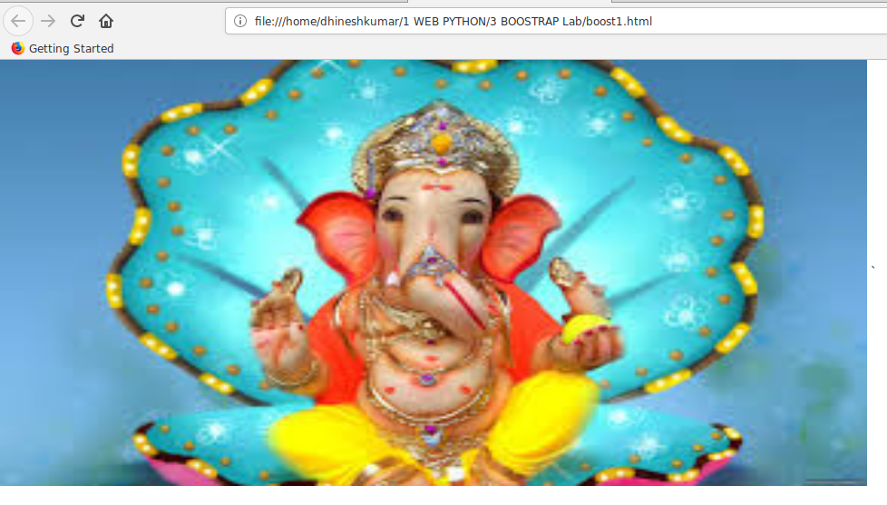

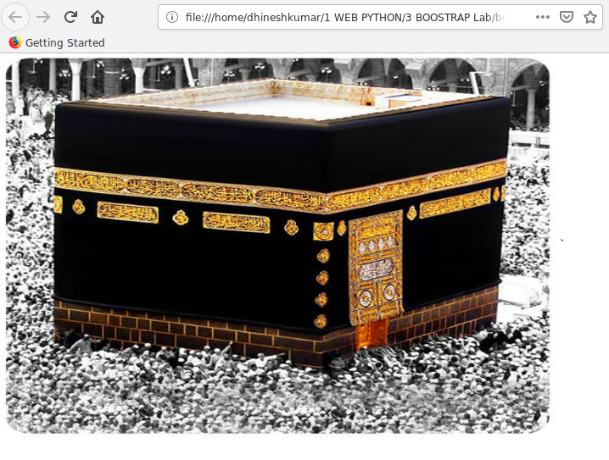

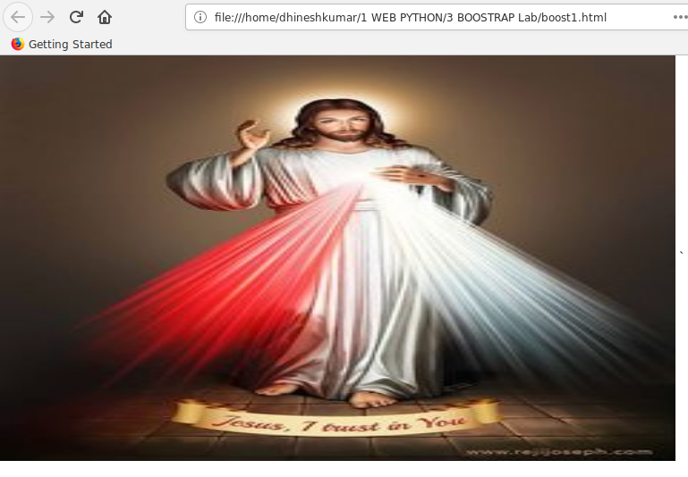

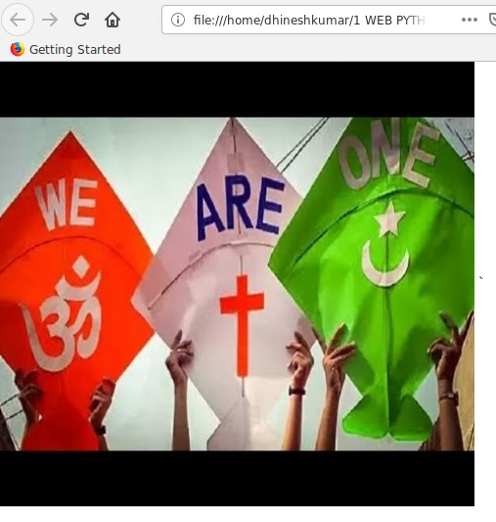

RESULT :
Thus, the given table example was designed using Boostrap .

Ex no: 12 | Developing a webpage using javascript
Date : | Developing a webpage using javascript

Question:1
Write a JavaScript function to find the sum of first n odd numbers and display the Result:.Get the
value of n from the user

Aim::
To Write a JavaScript function to find the sum of first n odd numbers and display the Result:.Get the
value of n from the user

Code::
<html>
<head>
<link rel="stylesheet" type="text/css" href="c.css">
</head>
<body>
<h2>The sum of n odd numbers</h2>
<script>
var n = Number(prompt("Enter N"));
add(n);
function add(n){
var i=0;
var n1=n;
var sum=0;
for(i=1;i<=n1;i++){
if(i%2!=0){
sum=sum+i;}}
document.write("n: ",n);
document.write("<br>sum: ",sum);}
</script>
</body>
</html>
Output
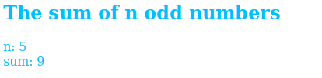

Result:
Hence we successfully Developed a webpage using javascript
Ex no: 12 | Developing a webpage using javascript
Date : | Developing a webpage using javascript

Question:2
Write a JavaScript function that checks occurence of substring in a given string

Aim:
To Write a JavaScript function that checks occurence of substring in a given string

Code:
<html>
<body>
<script>
var s=prompt("Enter string");
var s1=prompt("Enter substring");
if(s.search(s1)==0)
document.write("substring ",s1," is present in string ",s);
else
document.write("substring ",s1," is not present in string ",s);
</script>
</body>
</html>

Output
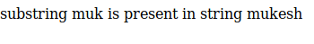

Result:
Hence we successfully Developed a webpage using javascript

Ex no: 12 | Developing a webpage using javascript
Date : | Developing a webpage using javascript

Question:3
Write a JavaScript function that accepts a string as a parameter and converts the first letter of
each word of the string in upper case

Aim:
To Write a JavaScript function that accepts a string as a parameter and converts the first letter of
each word of the string in upper case

Code:
<html>
<body>
<script>
function uppercase(str)
{
var arr = str.split(' ');
var arr1 = [];

for(var x = 0; x < arr.length; x++){
arr1.push(arr[x].charAt(0).toUpperCase()+arr[x].slice(1));
}
return arr1.join(' ');
}
a=prompt("ENter String to change");
document.write("given string is ",a,"<br>",uppercase(a));
</script>
</body>
</head>
Output:
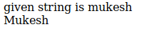

Result:
Hence we successfully Developed a webpage using javascript
Ex no: 13 | Developing webpage using javascript
Date : | Developing webpage using javascript

Question:1
Write a JavaScript program that displays the position of the first occurrence of "World" in the
variable txt

Aim:
To Write a JavaScript program that displays the position of the first occurrence of "World" in the
variable txt

Code:
<html>
<body>
<script>
a=prompt("ENter String ");
b=prompt("ENter String for inddex check");
var n = a.indexOf(b);
document.write(n);
</script>
</body>
</head>

Output

Result:
Hence we successfully Developed a webpage using javascript

Ex no: 13 | Developing a webpage using javascript
Date : | Developing a webpage using javascript

Question:2
Write a JavaScript function to remove specified number of characters from a string

Aim:
To Write a JavaScript function to remove specified number of characters from a string

Code:
<script>
function rem(str, char_pos)
{
a = str.substring(0,str.length-char_pos);
return a;
}
b=prompt("Enter string");
document.write(rem(b,3))
</script>
Output

Result:
Hence we successfully Developed a webpage using javascript
Ex no: 13 | Developing a webpage using javascript
Date : | Developing a webpage using javascript

Question:3
Create an HTML page with a textbox and a command button:When the user gives a number and presses the Calculate button, it has to alert the sum.

Aim:
To Create an HTML page with a textbox and a command button:When the user gives a number and presses the Calculate button, it has to alert the sum.

Code:
<html>
<head>
<script>
function fun(){
var n=document.getElementById("#").value;
var d=n.split('');
var sum=0;
for(i=0;i<d.length;i++){
sum=sum+Number(d[i]);]
alert(sum);]
</script>
<body>
<form>
<p>Text Box <input type="text" id="#" placeholder="Enter someting">
<button type="button" onclick="fun()">Click Here!</button>
</form>

Output
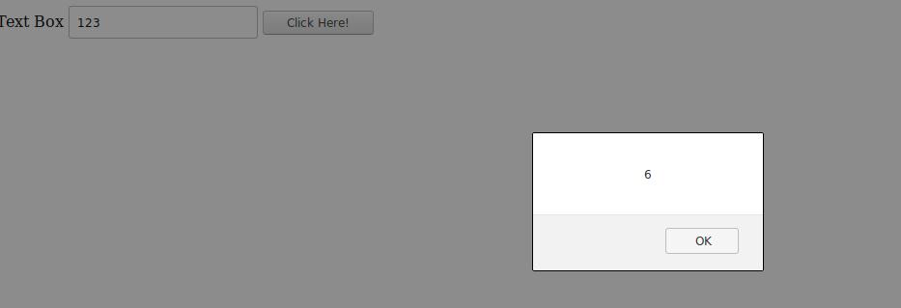

Result:
Hence we successfully Developed a webpage using javascript
Ex no: 14 | Developing a webpage using Regular Expression
Date : | Developing a webpage using Regular Expression

Question:1
Write a JavaScript program to check an Aadhar number(Format :9999-9999-9999)

Aim:
To Write a JavaScript program to check an Aadhar number(Format :9999-9999-9999)

Code:
<html>
<head>
<script type="text/javascript">
a=prompt("Enter aadhar nos");
is(a);
function is(str){
var creditPattern = /^\d{4}-\d{4}-\d{4}$/;
if (creditPattern.test(str)){
alert("Correct");}
else{
alert("Incorrect format");}}
</script>
</head>
Output:

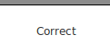

Result:
Hence we successfully Developed a webpage using Regular Expression
Ex no: 14 | Developinhg a webpage using Regular Expression
Date : | Developinhg a webpage using Regular Expression

Question:2
Write a JavaScript function that checks occurence of substring in a given string

Aim:
To Write a JavaScript function that checks occurence of substring in a given string

Code:
<html>
<head>
<script>
function validate(email,ph){
var email=document.getElementById("mk").value;
var ph=document.getElementById("mk1").value;
var emailp = /^[a-zA-Z0-9._-]+@[a-zA-Z0-9.-]+\.[a-zA-Z]{2,4}$/;
var phone = /^\d{10}$/;
if(emailp.test(email)==1 && phone.test(ph)==1)
alert("Email and Phone Number are correct format");
else
alert("In Correct");}
</script>
</head>
<body>
<form>
<p>Email:<input type="text" id="mk" placeholder="Enter Email">
<p>Phone Number:<input type="text" id="mk1" placeholder="Enter phone number">
<button type="button" onclick="validate()">Click Here!!!</button>
</body>
</html>

Output

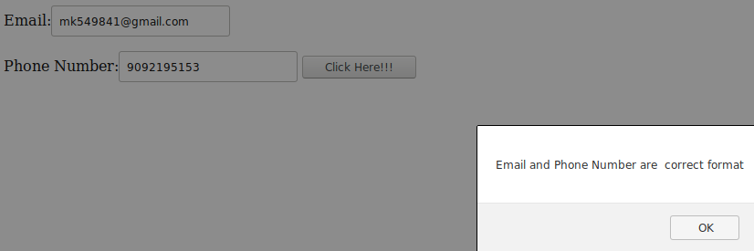

Result:
Hence we successfully Developed a webpage using Regular Expression

Ex no: 15 | Creating XML document for given data
Date : | Creating XML document for given data

Question:1
Create XML document for the following data: Student Registration Form Name Rahul Age 16 Gender Male Course C Programming

Aim:
To Create XML document for the following data: Student Registration Form Name Rahul Age 16 Gender Male Course C Programming

Code:
<<?xml version="1.0" ?>
<StudentRegistrationForm>
<name>Rahul</name>
<Age>"16></Age>
<Gender>Male</Gender>
<Course>C Programming</Course>
</StudentRegistrationForm>
</html>

Output

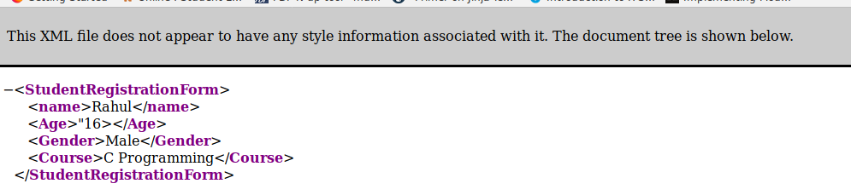

Result:
Hence we successfully Created XML document for given data
Ex no: 15 | Creating XML document for given data
Date : | Creating XML document for given data

Question:2
Check whether the following XML documents are well formed. If it is not well formed, correct the errors. <?xml version="1.0" encoding="iso-8859-1"?> <message> <email> <header> <sender>me@wipro.com</sender> <recipient>you@wipro.com</recipient> </header> <subject>Re: XML </subject> <text>I'm working on XML now. </email> </Messag

Aim:
To Check whether the following XML documents are well formed

Code:
<<?xml version="1.0" encoding="iso-8859-1"?>
<message>
<email>
<header>
<sender>me@wipro.com</sender>
<recipient>you@wipro.com</recipient>
</header>
<subject>Re: XML </subject>
<text>I'm working on XML now.</text>
</email>
</message>

Output

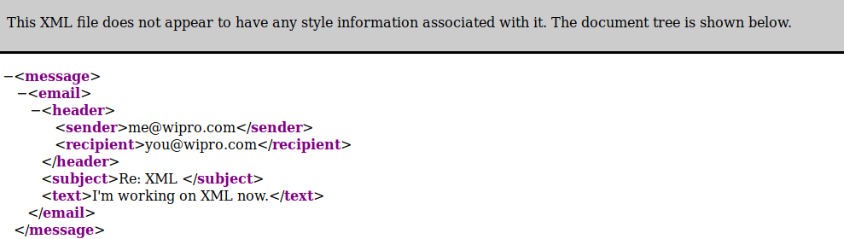

Result:
Hence we successfully Created XML document for given data
Ex no: 15 | Creating XML document for given data
Date : | Creating XML document for given data

Question:3
Develop DTD for the below given XML document: <address> <name>Manju</name> <company>Wipro</company> <phone>9988776655</phone> </address>

Aim:
To Develop DTD for the below given XML document: <address> <name>Manju</name> <company>Wipro</company> <phone>9988776655</phone> </address>

Code:
<?xml version="1.0"?>
<!DOCTYPE note [
<!ELEMENT address (name,company,phone)>
<!ELEMENT name (#PCDATA)>
<!ELEMENT company (#PCDATA)>
<!ELEMENT phone (#PCDATA)>
]>
<address>
<name>Manju</name>
<company>Wipro</company>
<phone>"9092191952"</phone>
</address>
Output:

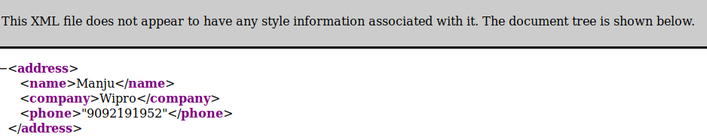

Result:
Hence we successfully Created XML document for given data
Ex no: 16 | Develop a DTD file for given XML document
Date : | Develop a DTD file for given XML document

Question:1
Develop DTD file for the below given XML document:
<?xml version="1.0"?>
<?xml-stylesheet href="catalog.xsl" type="text/xsl"?>
<!DOCTYPE catalog SYSTEM "catalog.dtd">
<catalog>
<product description="Cardigan Sweater" product_image="cardigan.jpg">
<catalog_item gender="Men's">
<item_number>QWZ5671</item_number>
<price>39.95</price>
<size description="Medium">
<color_swatch image="red_cardigan.jpg">Red</color_swatch>
<color_swatch image="burgundy_cardigan.jpg">Burgundy</color_swatch>
</size>
<size description="Large">
<color_swatch image="red_cardigan.jpg">Red</color_swatch>
<color_swatch image="burgundy_cardigan.jpg">Burgundy</color_swatch>
</size>
</catalog_item>
<catalog_item gender="Women's">
<item_number>RRX9856</item_number>
<price>42.50</price>
<size description="Small">
<color_swatch image="red_cardigan.jpg">Red</color_swatch>
<color_swatch image="navy_cardigan.jpg">Navy</color_swatch>
<color_swatch image="burgundy_cardigan.jpg">Burgundy</color_swatch>
</size>
<size description="Medium">
<color_swatch image="red_cardigan.jpg">Red</color_swatch>
<color_swatch image="navy_cardigan.jpg">Navy</color_swatch>
<color_swatch image="burgundy_cardigan.jpg">Burgundy</color_swatch>
<color_swatch image="black_cardigan.jpg">Black</color_swatch>
</size>
<size description="Large">
<color_swatch image="navy_cardigan.jpg">Navy</color_swatch>
<color_swatch image="black_cardigan.jpg">Black</color_swatch>
</size>
<size description="Extra Large">
<color_swatch image="burgundy_cardigan.jpg">Burgundy</color_swatch>
<color_swatch image="black_cardigan.jpg">Black</color_swatch>
</size>
</catalog_item>
</product>
</catalog>

Aim:
To Develop DTD file for the above given XML document:

Code:
<<?xml version="1.0" encoding="UTF-8"?>
<?xml-stylesheet href="4.xsl" type="text/xsl"?>
<!DOCTYPE catalog SYSTEM "4.dtd">

<catalog>
<product description="Cardigan Sweater" product_image="cardigan.jpg">

<catalog_item gender="Men's">
<item_number>QWZ5671</item_number>
<price>39.95</price>
<size description="Medium">
<color_swatch image="rose-blue-flower-rose-blooms-67636.jpg">Red</color_swatch>
<color_swatch image="burgundy_cardigan.jpg">Burgundy</color_swatch>
</size>

<size description="Large">
<color_swatch image="red_cardigan.jpg">Red</color_swatch>
<color_swatch image="burgundy_cardigan.jpg">Burgundy</color_swatch>
</size>
</catalog_item>

<catalog_item gender="Women's">

<item_number>RRX9856</item_number>
<price>42.50</price>
<size description="Small">
<color_swatch image="red_cardigan.jpg">Red</color_swatch>
<color_swatch image="navy_cardigan.jpg">Navy</color_swatch>
<color_swatch image="burgundy_cardigan.jpg">Burgundy</color_swatch>
</size>

<size description="Medium">
<color_swatch image="red_cardigan.jpg">Red</color_swatch>
<color_swatch image="navy_cardigan.jpg">Navy</color_swatch>
<color_swatch image="burgundy_cardigan.jpg">Burgundy</color_swatch>
<color_swatch image="black_cardigan.jpg">Black</color_swatch>
</size>

<size description="Large">
<color_swatch image="navy_cardigan.jpg">Navy</color_swatch>
<color_swatch image="black_cardigan.jpg">Black</color_swatch>
</size>

<size description="Extra Large">
<color_swatch image="burgundy_cardigan.jpg">Burgundy</color_swatch>
<color_swatch image="black_cardigan.jpg">Black</color_swatch>
</size>

</catalog_item>
</product>
</catalog>

Output

Result:
Hence we successfully Developed a DTD file for given XML document

Ex no: 16 | Develop a DTD file for given XML document
Date : | Develop a DTD file for given XML document

Question:2
Develop an XML file following the DTD file given below:
<!DOCTYPE TVSCHEDULE [
<!ELEMENT TVSCHEDULE (CHANNEL+)>
<!ELEMENT CHANNEL (BANNER,DAY+)>
<!ELEMENT BANNER (#PCDATA)>
<!ELEMENT DAY (DATE,(HOLIDAY|PROGRAMSLOT+)+)>
<!ELEMENT HOLIDAY (#PCDATA)>
<!ELEMENT DATE (#PCDATA)>
<!ELEMENT PROGRAMSLOT (TIME,TITLE,DESCRIPTION?)>
<!ELEMENT TIME (#PCDATA)>
<!ELEMENT TITLE (#PCDATA)>
<!ELEMENT DESCRIPTION (#PCDATA)>
<!ATTLIST TVSCHEDULE NAME CDATA #REQUIRED>
<!ATTLIST CHANNEL CHAN CDATA #REQUIRED>
<!ATTLIST PROGRAMSLOT VTR CDATA #IMPLIED>
<!ATTLIST TITLE RATING CDATA #IMPLIED>
<!ATTLIST TITLE LANGUAGE CDATA #IMPLIED>
]>
Aim:
To Develop an XML file following the DTD file given above

Code:
<?xml version="1.0"?>
<!DOCTYPE TVSCHEDULE [
<!ELEMENT TVSCHEDULE (CHANNEL+)>
<!ELEMENT CHANNEL (BANNER,DAY+)>
<!ELEMENT BANNER (#PCDATA)>
<!ELEMENT DAY (DATE,(HOLIDAY|PROGRAMSLOT+)+)>
<!ELEMENT HOLIDAY (#PCDATA)>
<!ELEMENT DATE (#PCDATA)>
<!ELEMENT PROGRAMSLOT (TIME,TITLE,DESCRIPTION?)>
<!ELEMENT TIME (#PCDATA)>
<!ELEMENT TITLE (#PCDATA)>
<!ELEMENT DESCRIPTION (#PCDATA)>
<!ATTLIST TVSCHEDULE NAME CDATA #REQUIRED>
<!ATTLIST CHANNEL CHAN CDATA #REQUIRED>
<!ATTLIST PROGRAMSLOT VTR CDATA #IMPLIED>
<!ATTLIST TITLE RATING CDATA #IMPLIED>
<!ATTLIST TITLE LANGUAGE CDATA #IMPLIED>
]>

<TVSCHEDULE NAME="vehicle launch">
<CHANNEL CHAN="111">
<BANNER> APACHE </BANNER>
<DAY>
<DATE>11/12/2019</DATE>
<HOLIDAY> YES </HOLIDAY>
<PROGRAMSLOT VTR="333">
<TIME RATING="7.9">10:35a.m</TIME>
<TITLE LANGUAGE="english"> HAHAHAH </TITLE>
<DESCRIPTION > BIKE REVIEWS </DESCRIPTION>
</PROGRAMSLOT>
</DAY>
</CHANNEL>
</TVSCHEDULE>
Output

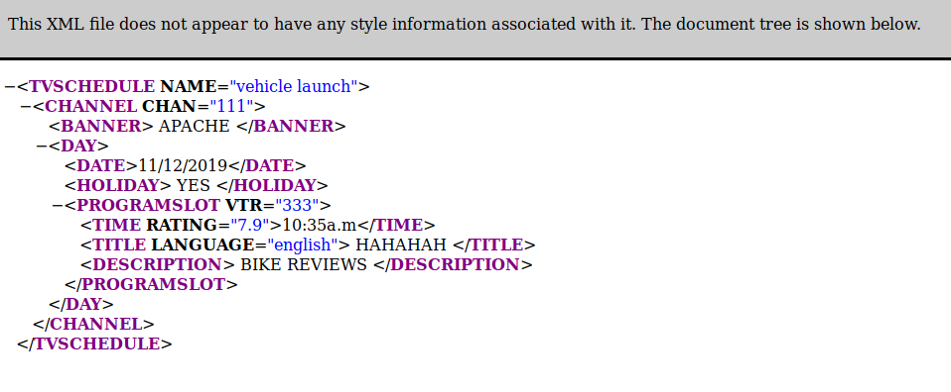

Result:
Hence we successfully Developed a DTD file for given XML document
Ex no: 17 | Developing a XML document to avoid Naming conflits
Date : | Developing a XML document to avoid Naming conflits

Question:1
Avoid Naming conflict in the following XML document:
<Phone>
<name>Moto E</name>
<ModelNo>123</ModelNo>
<Processor> Qualcomm Snapdragon 200 </Processor>
<Battery>2390 mAh</Battery>
</Phone>
<Phone>
<name>Beetel M71 Landline</name>
<ModelNo>456</ModelNo>
<Display>LCD Screen</Display>
<Corded>Yes</Corded>
</Phone>

Aim:
To Avoid Naming conflict in the above XML document:

Code:
<?xml version="1.0" encoding="UTF-8"?>
<Phone>
<s1:mobile xmlns:s1 = "www.google.com">
<s1:name>Moto E</s1:name>
<s1:ModelNo>123</s1:ModelNo>
<s1:Processor> Qualcomm Snapdragon 200 </s1:Processor>
<s1:Battery>2390 mAh</s1:Battery>
</s1:mobile>
<s2:mobile1 xmlns:s2 = "www.google.com">
<s2:name>Beetel M71 Landline</s2:name>
<s2:ModelNo>456</s2:ModelNo>
<s2:Display>LCD Screen</s2:Display>
<s2:Corded>Yes</s2:Corded>
</s2:mobile1>
</Phone>

Output

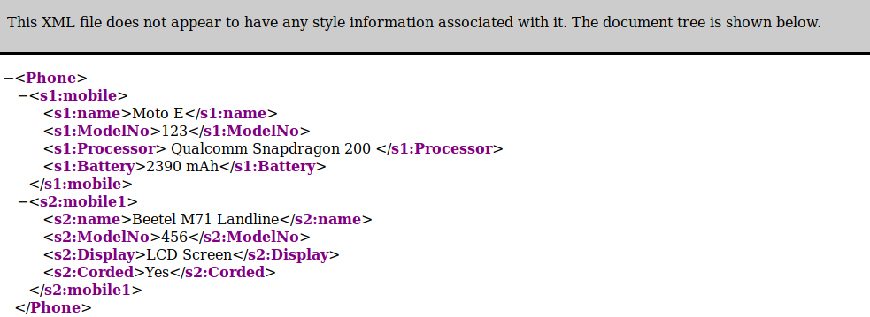

Result:
Hence we successfully Developed a XML document to avoid Naming conflits
Ex no: 18 | Develop a Schema file for a given XML file
Date : | Develop a Schema file for a given XML file

Question:1
Create and XSD file for the XML document given in the DTD

Aim:
To Create and XSD file for the XML document given in the DTD

Code:
<?xml version="1.0" ?>
<xs:schema xmlns:xs="http://www.w3.org/20001/XMLSchema.com">
<xs:element name="StudentRegistrationForm">
<xs:complexType>
<xs:sequence>
<xs:element name="name" type="xs:string"/>
<xs:element name="age" type="xs:int"/>
<xs:element name="Gender" type="xs:string"/>
<xs:element name="Course" type="xs:string"/>
</xs:sequence>
</xs:complexType>
</xs:element>
</xs:schema>
Output:

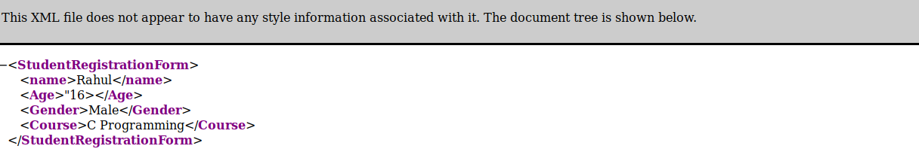

Result:
Hence we successfully Developed a Schema file for a given XML file
Ex no: 18 | Develop a Schema file for a given XML file
Date : | Develop a Schema file for a given XML file

Question:2
Create an XSD file for the XML document given in the DTD

Aim:
To Create an XSD file for the XML document given in the DTD

Code:
<?xml version="1.0" ?>
<xs:schema xmlns:xs="http://www.w3.org/20001/XMLSchema.com">
<xs:element name="message">
<xs:complexType>
<xs:sequence>
<xs:element name="email">
<xs:complexType>
<xs:sequence>
<xs:element name="sender" type="xs:string"/>
<xs:element name="recipient" type="xs:string"/>
</xs:sequence>
</xs:complexType>
</xs:element>
<xs:element name="subject" type="xs:string"/>
<xs:element name="text" type="xs:string"/>
</xs:sequence>
</xs:complexType>
</xs:element>
</xs:schema>
Output:
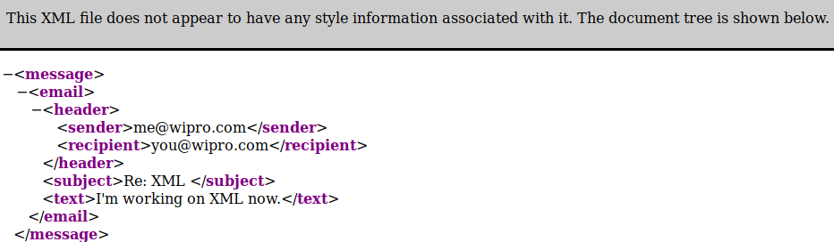
Result:
Hence we successfully Developed a Schema file for a given XML file
Ex no: 19 | Develop a webpage using Flask with HTML
Date : | Develop a webpage using Flask with HTML

Question:1
Design the following web page using Flask with HTML and render it for the route ‘/details’
Aim::
To Design the following web page using Flask with HTML and render it for the route ‘/details’
Code:
from flask import Flask, render_template
app = Flask(__name__)

@app.route('/')
def main():
return render_template('hello.html')
if __name__ == '__main__':
app.run(debug = True)
HELLO.HTML:
<!DOCTYPE html>
<html lang="en">
<head>
<meta charset="utf-8">
<title>Say hello</title>
</head>
<body>
<form>

<p> Title<select ><option value="volvo">Mr</option>
<option value="saab">Mrs</option></select></p>

<p>Name <input type='text' placeholder='Name'></p>
<p>City <input type='text' placeholder='City'></p>
<p>Country <input type='text' placeholder='Country'></p>
<p>Telephone <input type='text' placeholder='Telephone'></p>

<p>Please Inform us of your interest</p>
<input type="checkbox" name="vehicle1" value="Bike">Sports<br>
<input type="checkbox" name="vehicle2" value="Car">Music<br>
<input type="checkbox" name="vehicle3" value="Boat" >reading<br>
<input type="checkbox" name="vehicle3" value="Boat">Tv and Flim<br>

<p>Your Age</p>
<input type="radio" name="gender" value="male" checked>Less Than 25
<input type="radio" name="gender" value="female">26-40
<input type="radio" name="gender" value="other">41-65
<input type="radio" name="gender" value="other1">Over 65<br><br>
<input type="submit" value="submit">
</body>
</html>

Output

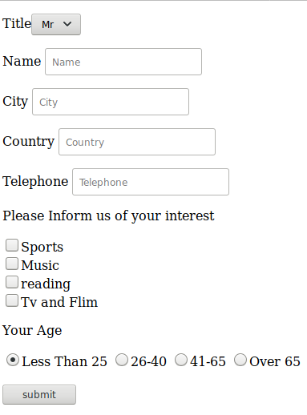

Result:
Hence we successfully Developed a webpage using Flask with HTML
Ex no: 19 | Develop a webpage using Flask with HTML
Date : | Develop a webpage using Flask with HTML

Question:2
Develop a web application using Flask based on the following routes:

/hello/ | Return the message “Good Morning!”

Aim:
To Develop a web application using Flask based on the following routes:

Code:
from flask import Flask
app = Flask(__name__)
@app.route('/hello/')
def hello():
return 'Good Morning !'
@app.route('/hello/<name>')
def hello1(name):
return '<h1>Good Morning! %s</h1>' %name
if __name__ == '__main__':
app.run(debug=True)

Output

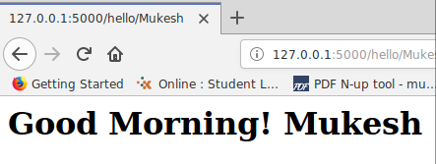

Result:
Hence we successfully Developed a webpage using Flask with HTML
Ex no: 20 | Develop a webpage using Flask with HTML
Date : | Develop a webpage using Flask with HTML

Question:1
Design the following web page using Flask

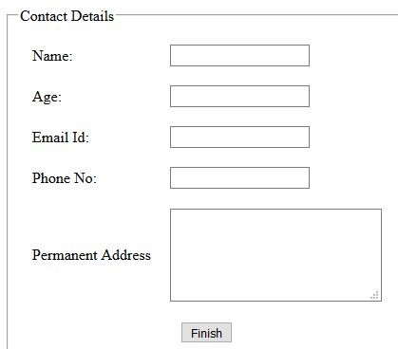

Aim:
To Design the following web page using Flask

Code:
from flask import *
app = Flask(__name__)
app.secret_key = "mukesh"

@app.route('/')
def home():
return render_template("home.html")

@app.route('/login')
def login():
return render_template("login.html")

@app.route('/success',methods = ["POST"])
def success():
if request.method == "POST":
session['name1']=request.form['name1']
session['age']=request.form['age']
session['email']=request.form['email']
session['pn']=request.form['pn']
session['pa']=request.form['pa']
return render_template('success.html')
@app.route('/profile')
def profile():
name1=session['name1']
age=session['age']
email=session['email']
pn=session['pn']
pa=session['pa']
return render_template('profile.html',a=name1,b=age,c=email,d=pn,e=pa)
if __name__ == '__main__':
app.run(debug = True)

Output:

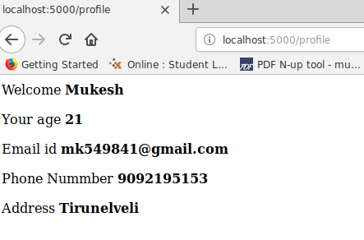

Result:
Hence we successfully Developed a webpage using Flask with HTML

Ex no: 20 | Develop a webpage using Flask with HTML
Date : | Develop a webpage using Flask with HTML

Question:2
Write a JavaScript function to remove specified number of characters from a string

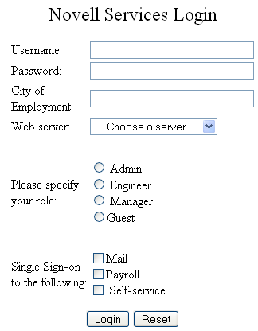

Aim:
Design the HTML form given below and render it for the route ‘/services’

Code:
from flask import Flask, render_template
app = Flask(__name__)

@app.route('/')
def main():
return render_template('hello1.html')
if __name__ == '__main__':
app.run(debug = True)
HELLO.HTML:
<!DOCTYPE html>
<html lang="en">
<head>
<meta charset="utf-8">
<title>Say hello</title>
</head>
<body>
<form>

<p> Title<select ><option value="volvo">Mr</option>
<option value="saab">Mrs</option></select></p>
<p>Name <input type='text' placeholder='Name'></p>
<p>City <input type='text' placeholder='City'></p>
<p>Country <input type='text' placeholder='Country'></p>
<p>Telephone <input type='text' placeholder='Telephone'></p>
<p>Please Inform us of your interest</p>
<input type="checkbox" name="vehicle1" value="Bike">Sports<br>
<input type="checkbox" name="vehicle2" value="Car">Music<br>
<input type="checkbox" name="vehicle3" value="Boat" >reading<br>
<input type="checkbox" name="vehicle3" value="Boat">Tv and Flim<br>
<p>Your Age</p>
<input type="radio" name="gender" value="male" checked>Less Than 25
<input type="radio" name="gender" value="female">26-40
<input type="radio" name="gender" value="other">41-65
<input type="radio" name="gender" value="other1">Over 65<br><br>
<input type="submit" value="submit">
</body>
</html>
Output:

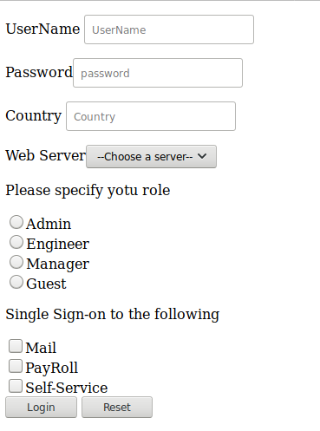

Result:
Hence we successfully Developed a webpage using Flask with HTML
Ex no: 21 | Design the given webpage using macros in jinga
Date : | Design the given webpage using macros in jinga

Question:1
Create a webpage to print your name on the screen with every letter having a different heading size.
(ii)Create a webpage that prints two lists with any information you want. One list should be an ordered list and the other list should be an unordered list
(iii)Create a webpage that will display an image that has a border of size 2, a width of 200px, and a height of 200px.
(iV)Develop a webpage to display the table having the columns (highlighted) as Decimal, English, Spanish, Korean, and Binary. Following are the data to be in each rows respective of their columns :
Aim:
To Create an HTML page with flask with above condition

Code:
from flask import Flask,render_template
from flask import *
app=Flask(__name__)

app.secret_key = "mukesh"

@app.route('/')
def login():
return render_template("login.html")

@app.route('/success',methods = ["POST"])
def success():
if request.method == "POST":
session['name1']=request.form['name1']
session['tele']=request.form['tele']
session['email']=request.form['email']
session['age']=request.form['age']
session['gender']=request.form['gender']
session['box']=request.form['box']
return render_template('success.html')
@app.route('/profile')
def profile():
name1=session['name1']
tele=session['tele']
email=session['email']
age=session['age']
gender=session['gender']
box=session['box']

return render_template('indexpage.html',a=name1,b=tele,c=email,d=age,e=gender,f=box)
if __name__ == '__main__':
app.run(debug=True)
INDEX.HTML:
{% from "sample.html" import w1 %}
{% from "sample.html" import w2 %}
{% from "sample.html" import w3 %}
{% from "sample.html" import w4 %}
{% from "sample.html" import w5 %}
{% from "sample.html" import w6 %}
<!DOCTYPE html>
<html>
<head>
</head>
<body>
{{w1(a)}}
{{w2(b)}}
{{w3(c)}}
{{w4(d)}}
{{w5(e)}}
{{w6(f)}}
</body>
</html>
Output:
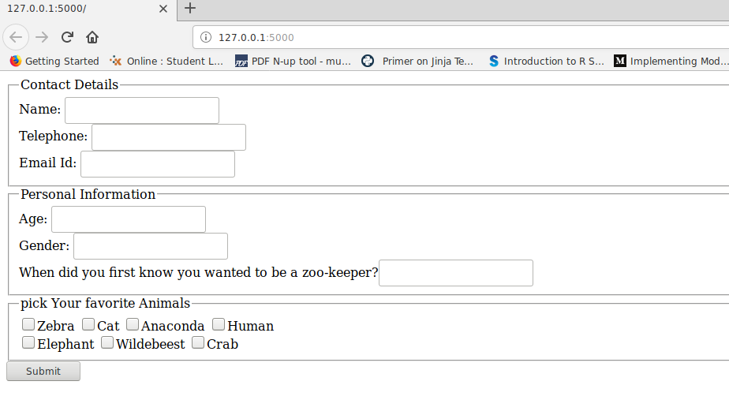

Result:
Hence we successfully Designed the given webpage using macros in jinga
Ex no: 22 | Design the webpage using template inheritance
Date : | Design the webpage using template inheritance

Question:1
Design a website for Ace Car Company based on the layout shown in figure [use template inheritance]:
- Header.html – the header must contain the name of the company and a logo at the left.
- Home.html – should contain a brief description about the company.
- Cars.html – should contain a table describing at least 5 car details
- Contact.html – should contain the address, phone number, fax and email id of the company.
- Footer.html – the footer must contain a copyright information of the company.
Aim:
To Design a web page using a template inheritance

Code:
from flask import Flask, render_template
app = Flask(__name__)
@app.route("/")
def template_test():
return render_template('header.html')
@app.route("/1")
def template_test1():
return render_template('home1.html')
@app.route("/2")
def template_test2():
return render_template('footer.html')
app.run(debug=True)
Header.html
{% extends "home.html" %}
{% block content %}

<!DOCTYPE html>
<html>
<head>
</head>
<body
{% endblock %}
</body>
</html>

footer.html
{% extends "contact.html" %}
{% block content %}
<footer>
<small>&copy; Copyright 2018, Example Corporation</small>
</footer>
{% endblock %}

Output:

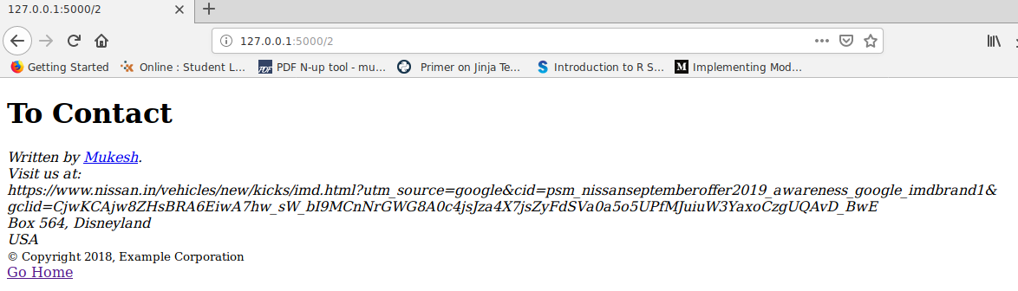

Result:
Hence we successfully Designed the webpage using template inheritance

Ex no: 23 | Implementing relationships using Sqlalchemy
Date : | Implementing relationships using Sqlalchemy

Question:1
Design an ORM for the given UML class diagram and also perform the following operations
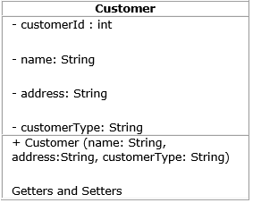

Create sequence for the customerId as 'seq_cust_id' starting with 5001. This field should be primary key .
2. Create and save 5 customer details.
3. Display the first record
4. Update the address of any customer .
5. Display customerId, name and customerType of all the customers.
6. Delete any two person from the table

Aim::
To Design an ORM for the given UML class diagram and also perform the following operations

Code::
from sqlalchemy.ext.declarative import declarative_base
from sqlalchemy import *
from sqlalchemy.orm import *
from sqlalchemy import exc
Base = declarative_base()

class customer(Base):
__tablename__ = "customers"
cust_id = Column(Integer, Sequence('seq_cust_id', start=5001), primary_key=True)
name = Column(String(25))
address = Column(String(35))
customer_type= Column(String(20))
# Constructor
def __init__(self,cust_id,name,address,customer_type):
self.cust_id=cust_id
self.name = name
self.address = address
self.customer_type = customer_type
# Getters
def get_id(self):
return self.cust_id
def get_name(self):
return self.name
def get_address(self):
return self.address
def get_type(self):
return self.customer_type
# Setters
def set_id(self, value):
self.cust_id = value
def set_name(self, value):
self.name = value
def set_address(self, value):
self.address = value
def set_type(self, value):
self.customer_type = value
def __repr__(self):
return f"CUSTOMER ID = {self.get_id()}\nNAME = {self.get_name()}\nADDRESS = {self.get_address()}\nCUSTOMER TYPE = {self.get_type()}"

Session = sessionmaker()
engine=create_engine("oracle://mk:1@localhost:1521/XE")
Base.metadata.create_all(engine)
session = Session.configure(bind=engine)
session = Session()
li=[]
print('Enter Five id ')
for i in range(5):
li.append(input())
li1=[]
print('Enter Five Name ')
for i in range(5):
li1.append(input())
li2=[]
print('Enter Five address ')
for i in range(5):
li2.append(input())
li3=[]
print('Enter Five Customer type ')
for i in range(5):
li3.append(input())
obj=customer(li[0],li1[0],li2[0],li3[0])
obj1=customer(li[1],li1[1],li2[1],li3[1])
obj2=customer(li[2],li1[2],li2[2],li3[2])
obj3=customer(li[3],li1[3],li2[3],li3[3])
obj4=customer(li[4],li1[4],li2[4],li3[4])
session.add(obj)
session.add(obj1)
session.add(obj2)
session.add(obj3)
session.add(obj4)
session.commit()
#3
print('First Record')
print(session.query(customer).first())
session.commit()
print(session.query(customer).all())
#4
print('Update the address of any customer .')
session.query(customer).filter_by(name=li1[0]).update({customer.address:'Covai'})
session.commit()
qry=session.query(customer).all()
print(qry)

print('Display customerId, name and customerType of all the customers.')
qry=session.query(customer.cust_id,customer.name,customer.customer_type).all()
print(qry)
print("Delete any two person from the table ")
session.query(customer).filter_by(name=li1[0]).delete()
session.query(customer).filter_by(name=li1[0]).delete()
session.commit()
qry=session.query(customer).all()
print(qry)
session.close()

Output:

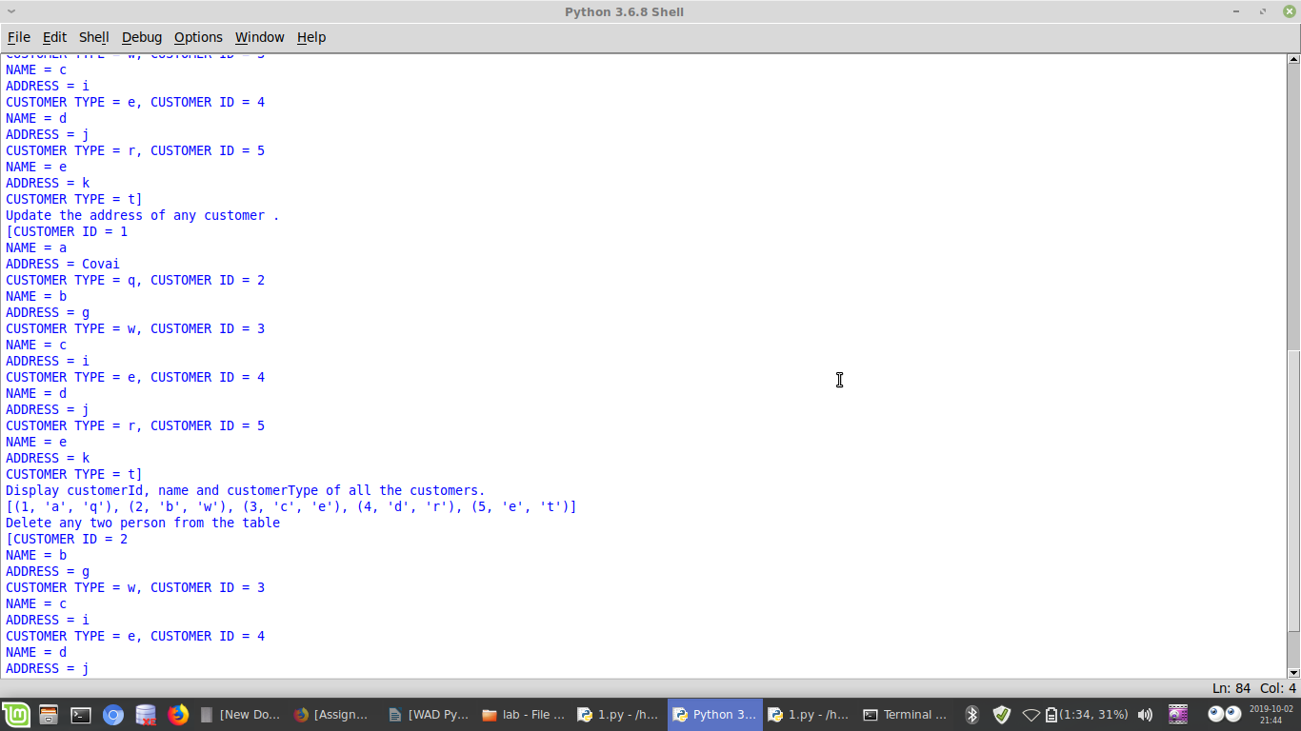

Result:
Thus web page has been successfully Implemented relationships using Sqlalchemy
Ex no: 23 | Implementing relationships using Sqlalchemy
Date : | Implementing relationships using Sqlalchemy

Question:2
Create a model class based on the one to many relationship given in the UML class diagram below and Insert all the details into the database using SQLAlchemy.
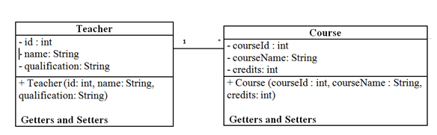

Aim:
To Create a model class based on the one to many relationship given in the UML class diagram below and Insert all the details into the database using SQLAlchemy.

Code:
from sqlalchemy.ext.declarative import declarative_base
from sqlalchemy import *
from sqlalchemy.orm import *
from sqlalchemy import exc
Base = declarative_base()
class Teacher(Base):
__tablename__ = "teachers"
id = Column(Integer, Sequence('author_id_seq'), primary_key=True)
name = Column(String(50))
qualification=Column(String(50))
course_id=Column(Integer)
course_name=Column(String(50))
course_credit=Column(Integer,primary_key=True)
course= relationship("Course", back_populates="teacher")
class Course(Base):
__tablename__ = "course"
c_id = Column(Integer)
c_name = Column(String(50))
credits1= Column(Integer, ForeignKey('teachers.course_credit'))
author = relationship("Author", back_populates="book")
def __repr__(self):
return("Course_id={}/nCourse_name={}/nCredits={}".format(self.c_id,self.c_name,self.credits1))
Session = sessionmaker()
engine=create_engine("oracle://mk:1@localhost:1521/XE")
Base.metadata.create_all(engine)
session = Session.configure(bind=engine)
session = Session()
obj=Teacher(1,'mk','be',12,'som',13)
obj1=Course(199,'Mukesh')
session.add(obj)
session.commit()
#print(session.query(Author).all())
print(session.query(Book).all())

Output:

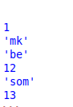

Result:
Thus web page has been successfully Implemented relationships using Sqlalchemy

Ex no: 24 | Developing web application using Flask-SQLAlchemy
Date : | Developing web application using Flask-SQLAlchemy

Question:1
Develop a web application for managing the Author details.
(i)Design a web page using HTML to read the Author details such as authorId,firstName and lastName.
(ii)Create a model class based on one to one relationship given in the UML class diagram below and Insert all the details into the database using Flask-SQLAlchemy.

Aim:
To Develop a web application for managing the Author details.

Code:
from flask import *
from flask_sqlalchemy import *
from sqlalchemy import *

app = Flask(__name__)
app.config['SQLALCHEMY_DATABASE_URI'] = 'oracle://mk:1@localhost:1521/xe'
app.config['SQLALCHEMY_TRACK_MODIFICATIONS'] = True
db = SQLAlchemy(app)

class user97(db.Model):
__tablename__ = 'mk1'
id =db.Column(db.Integer,db.Sequence('seq_book',start=1001),primary_key=True)
f_n= db.Column(db.String(80))
l_n = db.Column(db.String(120))
title= db.Column(db.String(80))
b= db.Column(db.String(80))

@app.route("/")
def index():
return render_template("login.html")
@app.route("/register", methods=["GET", "POST"])
def register():
if request.method == "POST":
a= request.form['f_name']
b= request.form['l_name']
c= request.form['hi']
d=request.form['ti']
register = user97(f_n=a,l_n=b,title=d,b=c)
db.session.add(register)
db.session.commit()
return render_template("wel.html")
if __name__ == "__main__":
db.create_all()
app.run(debug=True)
INDEX.HTML
<!DOCTYPE html>
<html>
<head>
</head>
<body>
<form method="POST" action="/register">
<p>First Name</p>
<p>
<input type='text' name='f_name' />
</p>
<p>Last name</p>
<p>
<input type='text' name='l_name' />
</p>
<p>Book Id</p>
<p>
<input type='text' name='hi' />
</p>
<p>Title</p>
<p>
<input type='text' name='ti' />
</p>
<button type="submit" >Submit</button>
</div>
</form>
</body>
</html>

Output:

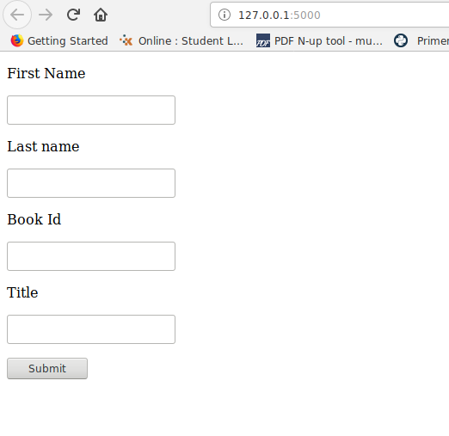

Result:
Thus we successfully Developed the web application using Flask-SQLAlchemy
Ex no: 24 | Developing web application using Flask-SQLAlchemy
Date : | Developing web application using Flask-SQLAlchemy

Question:2
Develop a web application for managing the Bank Account details of a customer in which one customer can have only one account. Design a web page using HTML to read the customer details such as name, address, phone number and account type (Savings or Salary).

Aim:
To Develop a web application for managing the Bank Account details of a customer in which one customer can have only one account. Design a web page using HTML to read the customer details such as name, address, phone number and account type (Savings or Salary).

Code:
from flask import *
from flask_sqlalchemy import *
from sqlalchemy import *

app = Flask(__name__)
app.config['SQLALCHEMY_DATABASE_URI'] = 'oracle://mk:1@localhost:1521/xe'
app.config['SQLALCHEMY_TRACK_MODIFICATIONS'] = True
db = SQLAlchemy(app)
class user97(db.Model):
__tablename__ = 'mk2'
id =db.Column(db.Integer,db.Sequence('seq_book',start=1001),primary_key=True)
Name = db.Column(db.String(80))
Address = db.Column(db.String(120))
Phone= db.Column(db.String(80))
@app.route("/")
def index():
return render_template("register.html")
@app.route("/register", methods=["GET", "POST"])
def register():
if request.method == "POST":
uname = request.form['uname']
mail = request.form['mail']
passw = request.form['passw']
register = user97(Name= uname,Address= mail,Phone= passw)
db.session.add(register)
db.session.commit()
return render_template("wel.html")
if __name__ == "__main__":
db.create_all()
app.run(debug=True)

INDEX.HTML:
<!DOCTYPE html>
<html>
<head>
</head>
<body>
<form method="POST" method="POST" action="/register">
<p>Name</p>
<p>
<input type='text' name='uname' />
</p>
<p>Address</p>
<p>
<input type='text' name='mail' />
</p>
<p>PhoneNumber</p>
<p>
<input type='text' name='passw' />
</p>
<input type = "submit" value = "Submit">
</div>
</form>
</body>
</html>

Output:

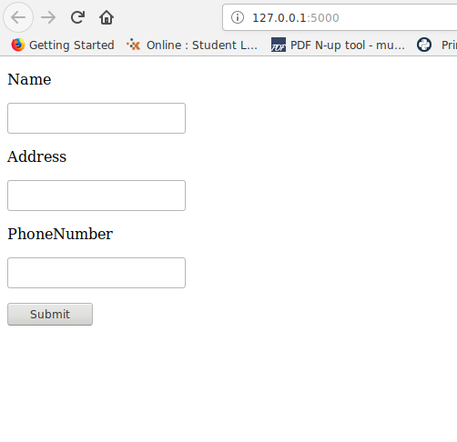

Result:
Thus we successfully Developed the web application using Flask-SQLAlchemy
Ex no: 24 | Developing web application using Flask-SQLAlchemy
Date : | Developing web application using Flask-SQLAlchemy

Question:3
Design the following web page using Flask-SQLAlchemy:

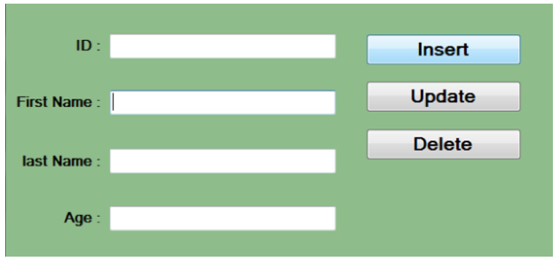

Aim:
To Design the following web page using Flask-SQLAlchemy:

Code:
from flask.app import Flask
from flask.globals import request
from flask.templating import render_template
from flask_sqlalchemy import SQLAlchemy
app = Flask(__name__)
app.config['SQLALCHEMY_DATABASE_URI']='oracle://mk:1@localhost:1521/XE'
db=SQLAlchemy(app)
class Book(db.Model):
__tablename__ = 'books_tbl'
id =db.Column(db.Integer,db.Sequence('seq_book',start=1001),primary_key=True)
title=db.Column(db.String(25))
price=db.Column(db.Float)
author=db.relationship("Author",back_populates='book')
def __repr__(self):
return f"<Book(title={self.title},price=Rs.{self.price},author={self.author})>"
class Author(db.Model):
__tablename__='authors_tbl'
id = db.Column(db.Integer,db.Sequence('seq_author',start=5001),primary_key=True)
name=db.Column(db.String(20))
bookid = db.Column(db.Integer,db.ForeignKey('books_tbl.id'))
book = db.relationship("Book",back_populates='author')
def __repr__(self):
return f"<Author(name={self.name})>"
@app.route('/')
@app.route('/book',methods=['GET','POST'])
def book_store():
if request.method=='GET':
return render_template('bookstore.html')
elif request.method=='POST':
title=request.form['title']
author_name=request.form['author']
price=request.form['price']
option=request.form['option']
if option=='Add':
author=Author(name=author_name)
book=Book(title=title,author=[author],price=price)
db.session.add(book)
db.session.commit()
elif option=='Update':
book=Book.query.filter(Book.title==title).one()
book.price=price
db.session.commit()
elif option=='Delete':
book=Book.query.filter(Book.title==title).one()
db.session.delete(book)
db.session.commit()
else:
books=Book.query.all()
return render_template('show.html',books=books)

return render_template('bookstore.html')
if __name__=="__main__":
db.create_all()
app.run(debug=True)

Output

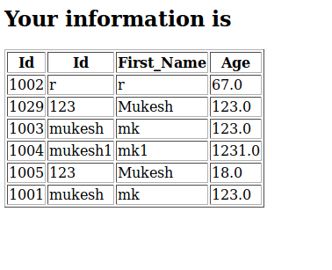

Result:
Thus we successfully Developed the web application using Flask-SQLAlchemy.

